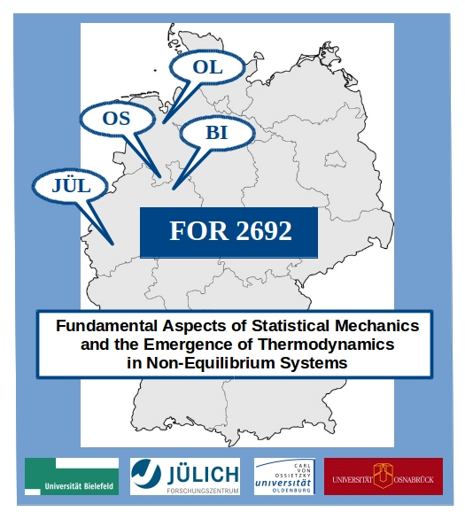
International workshop
“Out-of-equilibrium dynamics in many-body systems”

24 – 26. September 2018, Osnabrück

– Application form –

Personal information:

First name:
Last name:
Title:
Affiliation:
Position:
Office address:
Private address:
Email:
Phone:

Contribution:

Poster: | yes / no
Title of poster:
Day of arrival:
Day of departure:

Please send this form by email to

University Osnabrück, Physics Department, Mrs. Michaela Horstkott, mhorstkott@uos.de

until 30. June 2018.

